**Nikhil P G**

**1NT20IS408**

**Big Data Lab**

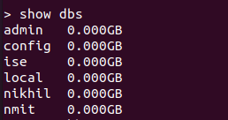show db

**Use Db**



Create Collection



Drop collection

Insert Collection:

Insert many:

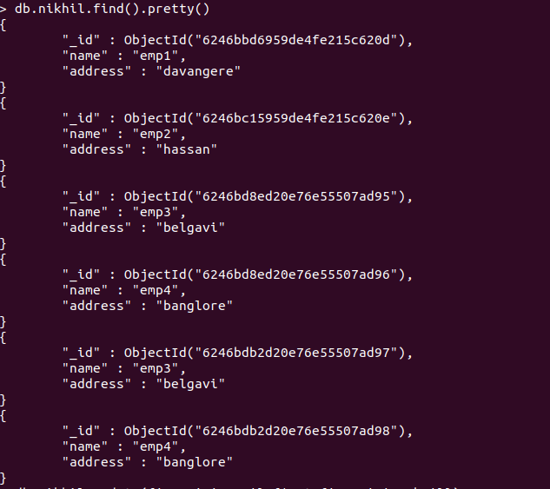

Remove command:

Update command:

Replace Command:

OR:



And: